Banking System

**CSD 3464 - Java Programing SE**

**Submitted To – Submitted by -**

**Mr. Vasil Khachidze Kawaljeet Kaur (C0850339)**

**Ishdeep Singh (C0852674)**

**Kruti Patel(C0850114)**

**Ravneet Singh(C0846714)**

**Vishwa Patel(C0854573)**

**Harmanpreet Kaur(C0853209)**

**Table of Contents**

**Overview 3**

**Features of Java 3**

**Java Programming Language Elements 3**

**Usage of java 4**

**Technologies used in it 5**

**Core Java 6**

**About Project 7**

**Authentication Page 9**

**Loading Page 10**

**Profile Module 11**

**Deposit Module 12**

**Money Transfer 13**

**Withdrawal Module 14**

**Customer List 15**

**Transaction Window 16**

**View Balance 17**

**Change PIN module 18**

**About 19**

**References 20**

**Overview-**

Sun Microsystems initially introduced Java, a programming language and computing platform, in 1995. It has grown from its modest origins to power a significant portion of the digital world of today by offering the solid foundation upon which numerous services and applications are developed. Java is still used in cutting-edge goods and digital services that are being developed for the future.

Although many current Java applications integrate the Java runtime with the application, there are still plenty of programmers and even certain websites that require a desktop Java installation in order to work. This website, Java.com, is made for users who might still need Java for desktop programmers, particularly those that support Java 8. Both consumers and developers that want to understand Java programming

**Features of Java**

# One of the simpler programming languages to learn is this one.

# Run your code once on virtually any computing platform.

# Java works across all platforms. It is possible to run some programmers created on one system on another.

# The creation of object-oriented programmers is its intended use.

# This language has autonomous memory management and is multithreaded.

# It was developed for the distributed Internet environment.

**Java Programming Language Elements**

A Java programmer creates a program in Source Code, a human-readable language. As a result, the CPU or Chips are unable to comprehend any programming language's source code.

These processors or computers exclusively comprehend machine language, also known as code. These computer programs operate at the CPU level. As a result, for other CPU models, it would be different machine codes.

However, since programming is all about the source code, you must be concerned about the machine code. This source code is understood by the computer, which then converts it into executable code that the computer can understand.

**Usage of java**

Java is used to create programs that run on a single device, such as a desktop or smartphone, and supports programs that run on a variety of platforms that support JRE. The creation of distributed applications using Java is another option. That implies that a single program can run synchronously while being spread among servers or clients in a network. As an additional component of web pages, Java can be used to create application modules or applets.

Java is employed in:

* GUI programs
* Application servers and web servers
* middleware programs
* Web-based programs
* Mobile programs
* Embedded devices
* Enterprise software

**Technologies used in it**

**Java swing-**

A handy framework for creating Java GUI widgets, Java Swing comes with a wide variety of widgets. It contains a number of packages for creating sophisticated desktop applications in Java and is a component of the Java Foundation Classes (JFC). Swing has built-in controls for displaying HTTP or rich text format, including trees, image buttons, tabbed windows, sliders, toolbars, tables, and text fields (RTF). Because Swing components are entirely written in Java, they are platform neutral.

**SQL Lite-**

A self-contained, serverless, zero-configuration, transactional SQL database engine is implemented by SQLite, an in-process library. This database is zero-configured, therefore unlike other databases it does not require any system configuration.

Unlike other databases, the SQLite engine can be linked statically or dynamically with your application depending on your needs. Direct access to storage files is how SQLite works.

**Core Java –**

The word **Core** describes the basic concept of something, and here, the phrase 'Core Java' defines the basic Java that covers the basic concept of Java programming language. We all are aware that Java is one of the well-known and widely used programming languages, and to begin with it, the beginner has to start the journey with Core Java and then towards the [Advance Java](https://www.javatpoint.com/what-is-advance-java). The [Java programming language](https://www.javatpoint.com/java-tutorial) is a general-purpose programming language that is based on the OOPs concept. The ocean of Java is too deep to learn, i.e., as much you learn more, you will know its depth. Java is a platform-independent and robust programming language. The principle followed by Java is **WORA** that says Write Once, Run Anywhere. The programming language is quite simple and easy to understand. But one should know that Core Java is not different from Java. Java is complete in itself, but for the beginners, it is natural that the beginner must begin with the core concepts of Java. In actual, Java has different editions, where Core Java is one of the parts of an edition.

## **Java Edition used in the project**

The [Java SE](https://www.javatpoint.com/java-se) is a computing-based platform and used for developing desktop or Window based applications. Thus, core Java is the part of Java SE where the developers develop desktop-based applications by using the basic concepts of Java where [JDK (Java Development Kit)](https://www.javatpoint.com/difference-between-jdk-jre-and-jvm#jdk) is a quite familiar Java SE implementation.

**About Project-**

Banking applications have all focused-on customer and their journey since banking started as an enterprise. We have always ensured that customer is the king and all services provided to customers have been validated as being valuable. The bank evolved into being a part of the family for the customer and their financial expectations from loans to investments and retirements are all managed by the bank. The application requirements from the customer perspective include the following:

* Access to all accounts, balances, and transactions with up to date status
* All transactions and associated details
* All credit card accounts
* All loan accounts
* All investment accounts
* All household information

The expectation is one [application interface](https://www.sciencedirect.com/topics/computer-science/application-interface) with access, security, device support, interactive call center support, and more robotic assistance with real person support as needed. Where do we lose sight of this customer and their expectations? How do we proactively engage with this opportunity to turn it to the advantage of the bank while benefiting the customer? This is where the application development for predicting will take form and shape.

Time is valued today in the same way as money. No one wants to spend their half day at the bank for tasks like money transfers and balance inquiries. You may handle your most critical financial tasks from the comfort of your home thanks to the comprehensive banking system that is designed in Java.

**Project Name-Banking System**

**Project type- Web Application**

**Operating System-Window10**

**Necessary software for this project-**

* You need to install java Eclipse IDE
* DB browser to show data of the project

With the help of banking system project users of the Complete Banking System can access their accounts and general information about the products and services of the bank from the convenience of their PC. With a valid user ID and password, any authenticated user will be able to access the secure banking system that this application attempts to provide. The user has access to his account through this system from any location.

Modules which are included in this project are

Login module

Profile module

Deposit module

Money transfer

Withdrawal module

View balance module

Change PIN module

**Authentication page-**

A user must create a special ID and key during account registration to later access their account. The ID and key are typically a username and password, although other sorts of keys can also be included in the credentials.

In essence, the user authentication procedure works to prevent unauthorized users from accessing accounts while granting individuals repeated access to their own accounts. This is the authentication page of our project where user need to enter their account no and pin to enter the Banking system. This window also must feature to add a new account.

**Loading page**

This loading gif makes perfect sense given that the website that is the source of it is a brewery. It illustrates how the brewery's products are made, which not only eases customers' frustration while they wait for the page to load but also ingeniously piques their interest.

After entering the login information this window is appeared and it show processing timing before opening the main window .

**Profile module**

Next is the profile window in which when user enter his name it show his personal information like name of the account holder, account no, account type, Date of birth, Nationality, Gender, caste, mobile, security question.in profile page user have also, have the ability to edit their profile in some particular fields like their security question, address, mobile no etc. After that user can save it by clicking on save button.

**Deposit module**

This page show how a account holder deposit their money into account also, it show their total account balance. In this user check their name, account no, available balance and deposit amount.

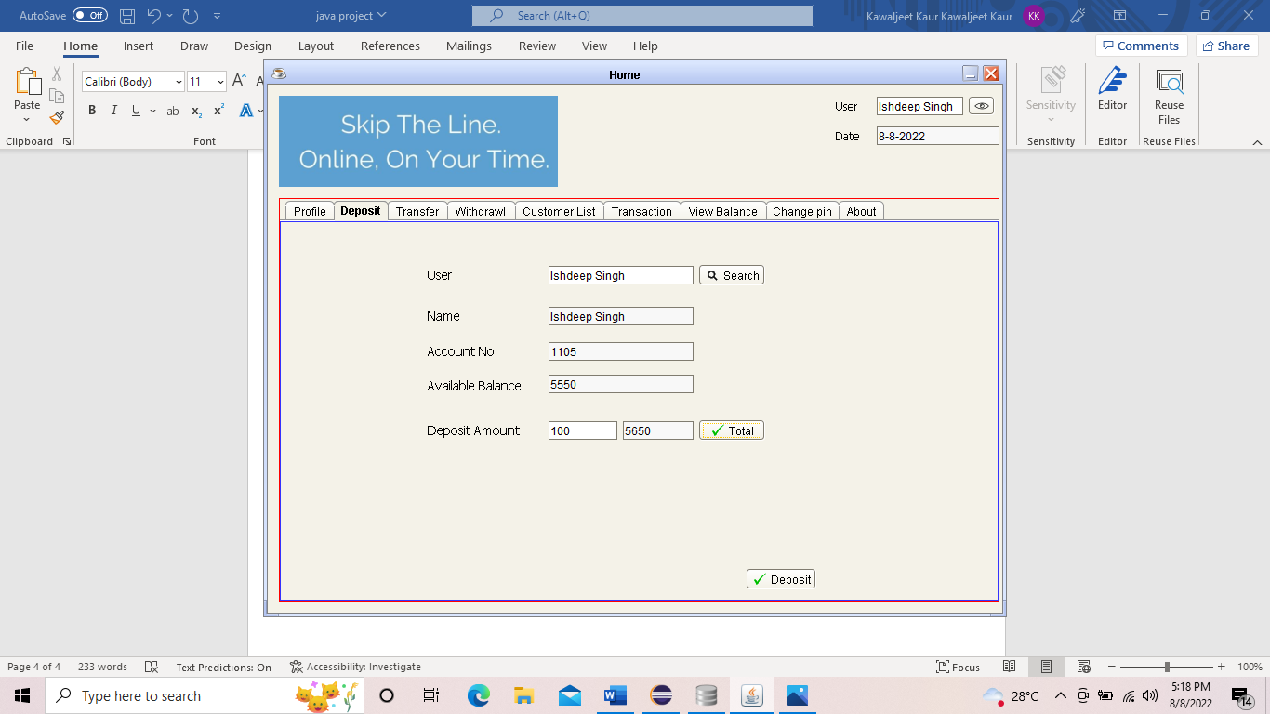

It also, show deposit message when we click on deposit

**Money Transfer**

In the transfer page user is able to transfer their money into their credit account it also show transfer message when user transfer their money .

**Withdrawal module**

Next is the withdrawal window in which user withdrawal their money by entering their information. This window has buttons like username, account no, account balance, amount, total and withdrawal button .

**Customer List**

This page show information of users who have opened their accounts in this banking system it shows their all information like their account no, name, DOB, account type, gender and mobile no.

**Transaction window**

It is a transaction window which show username, account no, MICR no, and balance into account

**View balance**

In the view balance page user know about their available balance and interest rate and other things.

**Change PIN module**

Next is the change pin window in which user can change their pin by entering a new pin

**About**

In the Last this is the about page

**References**

1. <https://www.geeksforgeeks.org/java/>
2. <https://www.techonthenet.com/java/index.php>
3. <https://www.javatpoint.com/>
4. <https://www.w3schools.com/java/>
5. <https://www.javahelps.com/2015/04/>
6. https://www.javaguides.net/